# Start program

Basic run off Web application, Learners Academy and Home are buttons and goes here

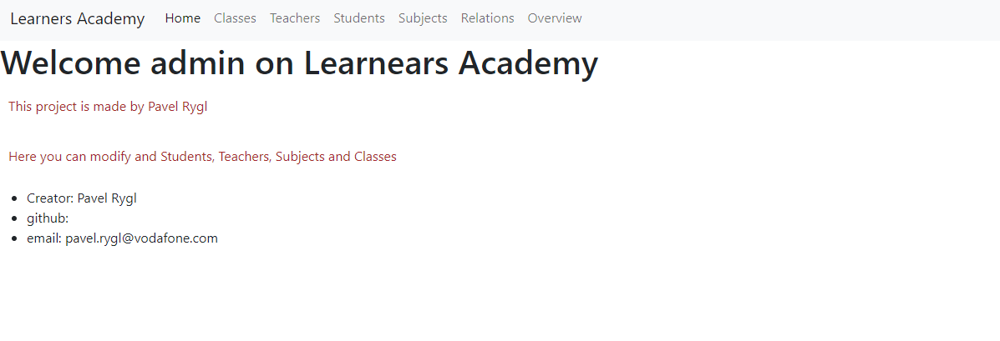

## Class table

Here are displayed all Classes and also can add new class, edit or delete it

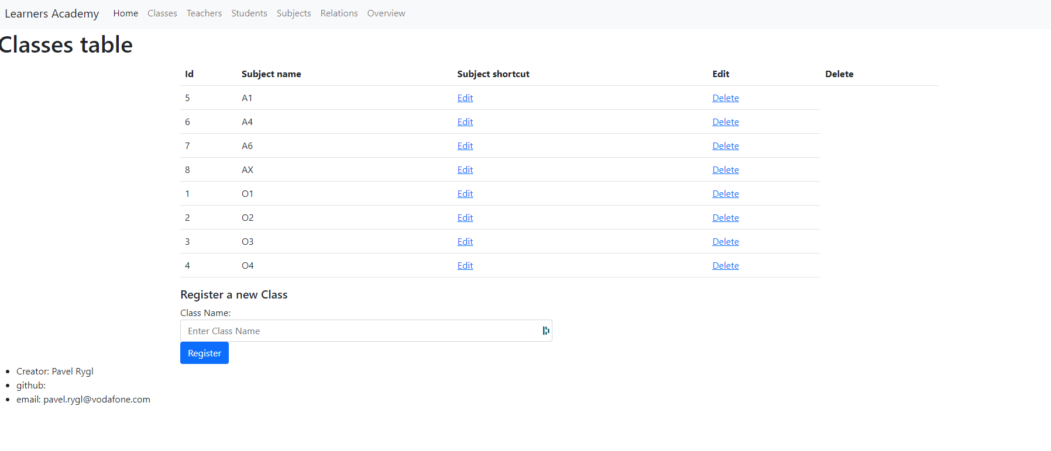

## Student table

Here are displayed all Students and also can add new student, edit or delete it

As you can see, there is not reusing Ids, which could cause problems.

Email and phone number not mandatory

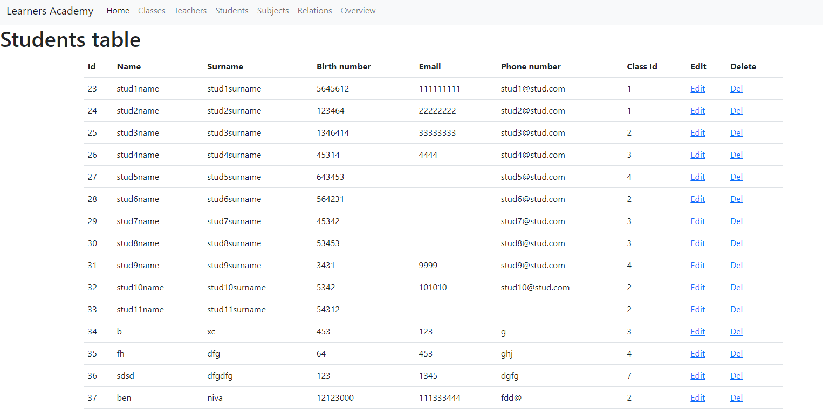

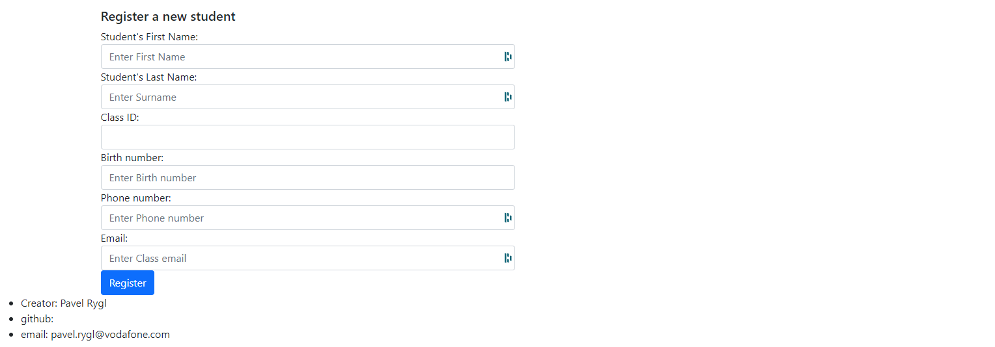

## Subject table

Here are displayed all Subjects and also can add new subject, edit or delete it

As you can see, there is not reusing Ids, which could cause problems.

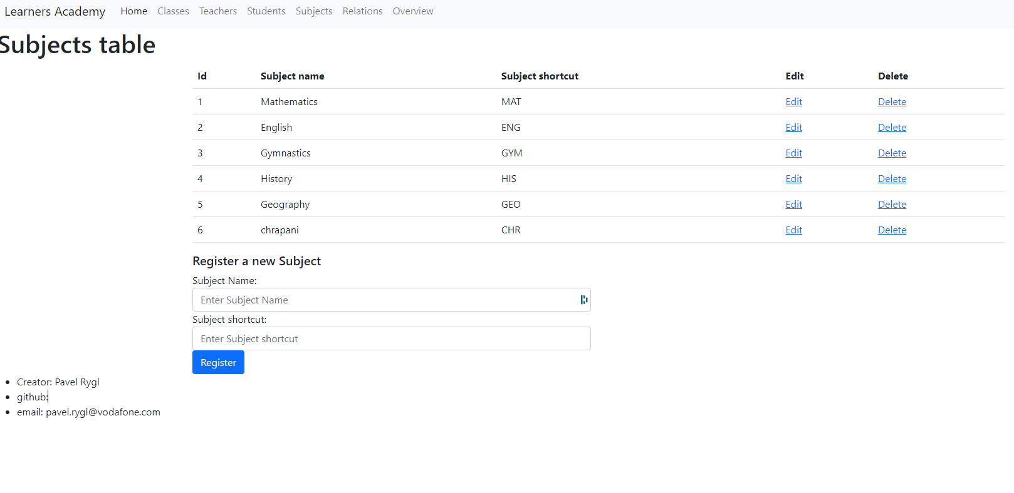

## Teacher Table

Here are displayed all Teachers and also can add new student, edit or delete it

As you can see, there is not reusing Ids, which could cause problems.

Email and phone number not mandatory

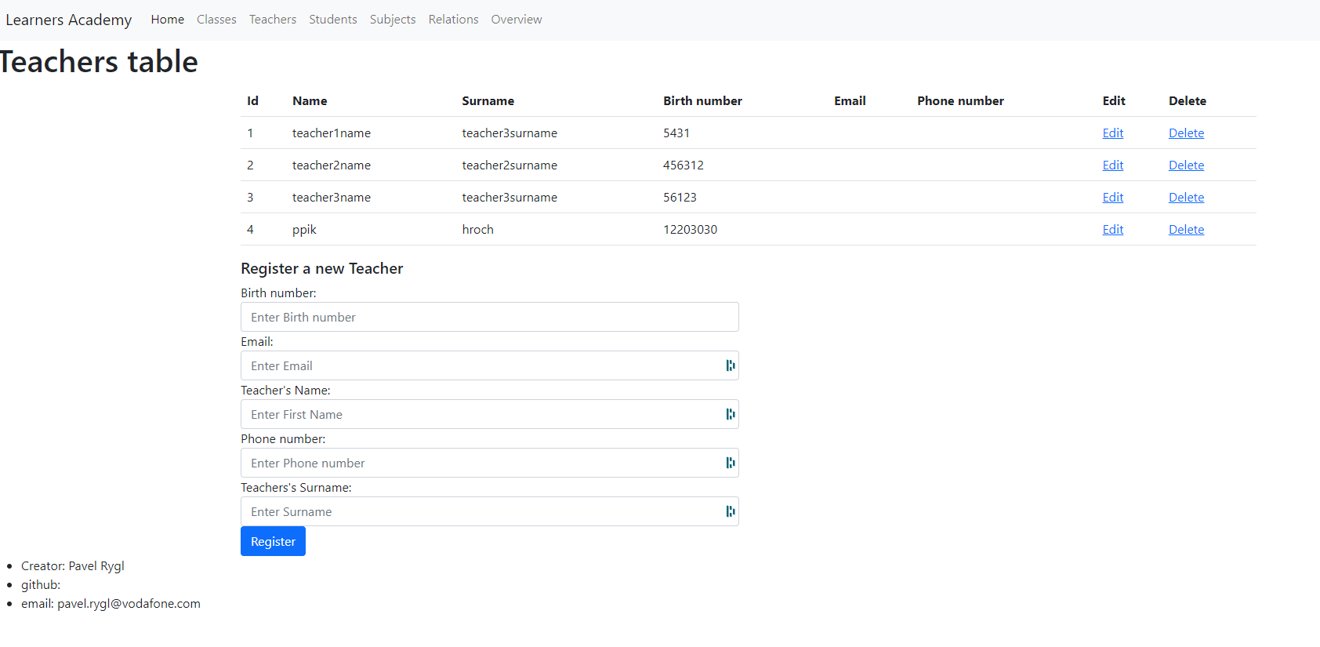

# Database view

For this poject is used learners_academy databes.

It has 5 tables, which stores objects.

Classessubjectsteacherlink is for grouping students subjects and teachers together.

